WEB APPLICATION DEVELOPMENT

PART A:

VS code:

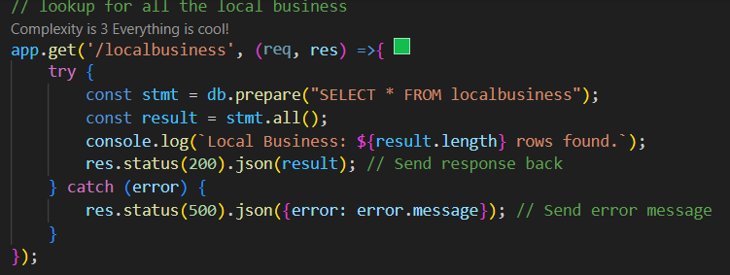

Rester extension:

Routes.rest:

TASK 1:

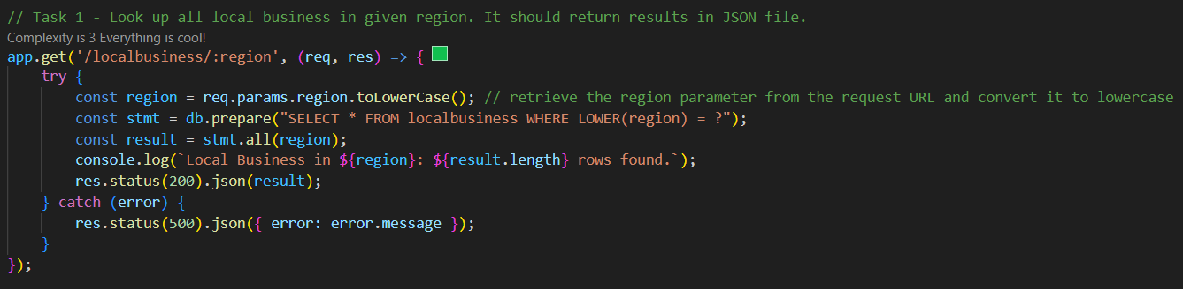

TASK 2: ADD NEW BUSINESS

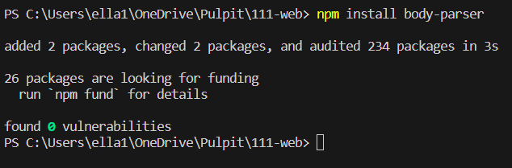

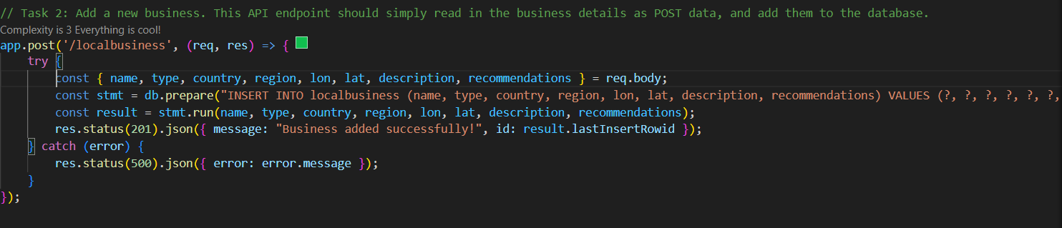

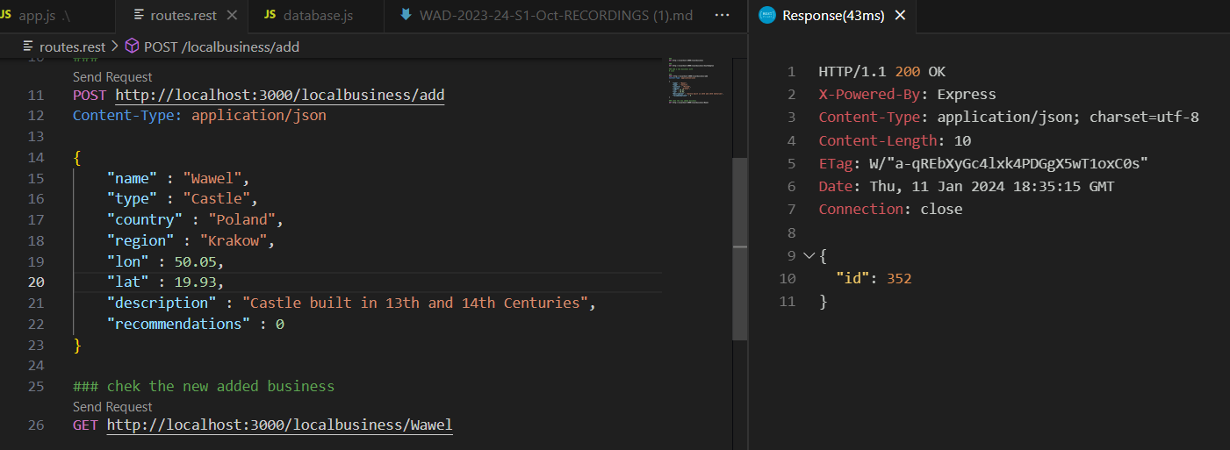

Task 3 : add recommendations

Extra task: delete business if the id =?

In this case id 353- where Wawel Castle was added twice paired with new id.

GITHUB: